**Tutorial 8: Dynamic classes**

Dynamic classes allow us to display css values dynamically if the value is set to true. We will explore this further in the tutorial.

Make sure **Tutorial 7** is complete to be able to move on to this tutorial or clone the [vue3-firebase-course](https://github.com/younggrasshopperza/vue3-firebase-course) repository and go to branch called **Tutorial-7**.

In the **index.html** file, make sure the **body** tag has the below code:

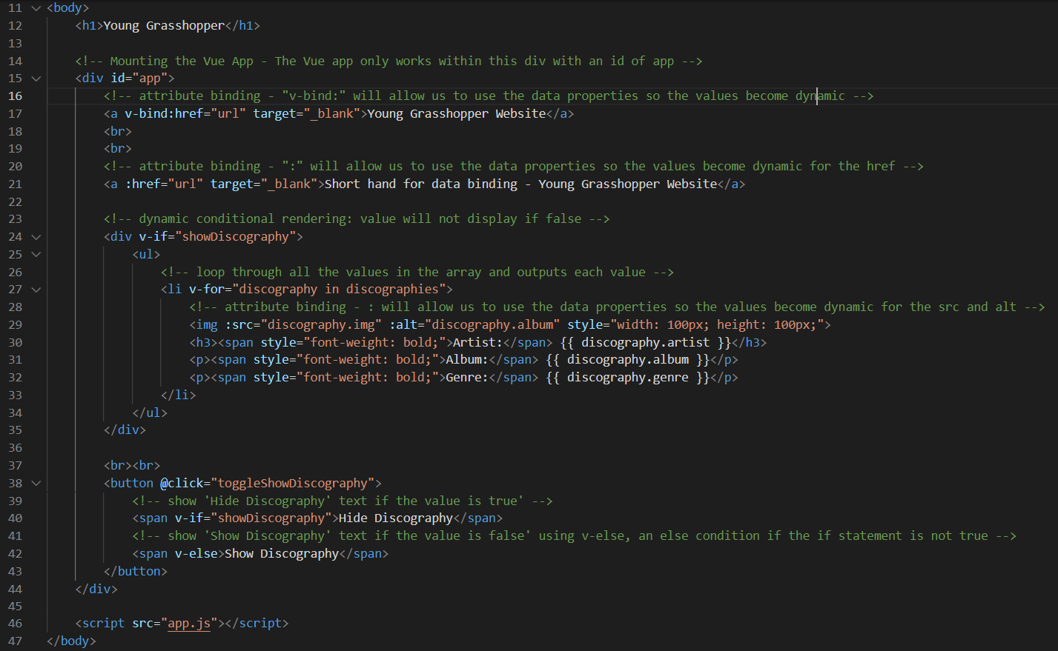

In the **app.js** file, make sure the code looks like the below:

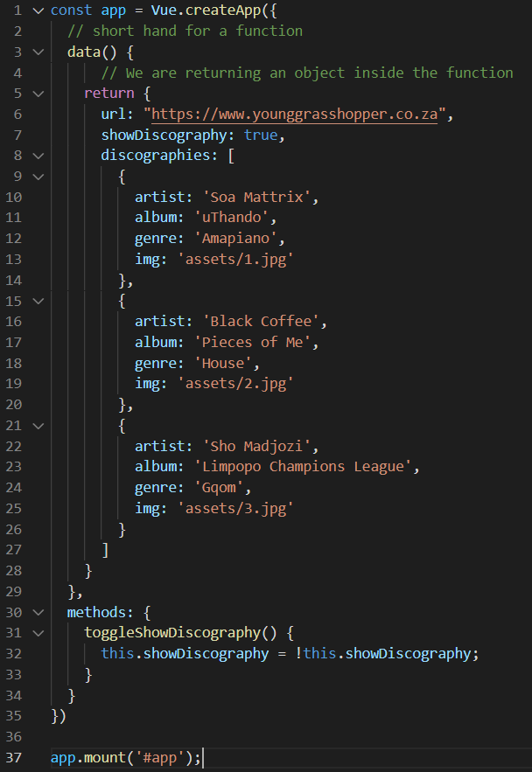

**Step 1:** Create a **CSS** file called **style.css** and link it to the **index.html** head tag.

Look at the example below (**Line 10**):

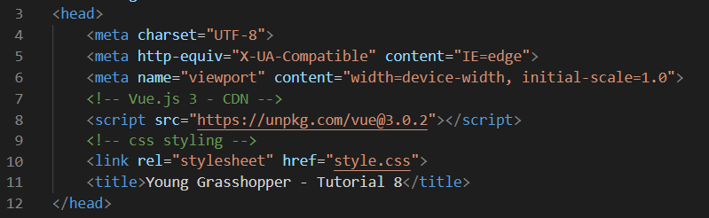

The CSS code is below (**copy and paste the code**):

body {

    background: #eee;

    max-width: 960px;

    margin: 20px auto;

    font-family: cursive;

}

button {

  background: #04AA6D;

  color: #fff;

  border: none;

  border-radius: 5px;

  height: 30px;

  box-shadow: 0 12px 16px 0 rgba(0,0,0,0.24), 0 17px 50px 0 rgba(0,0,0,0.19);

}

button:hover {

  background: #fff;

  color: #04AA6D;

  border-radius: 5px;

  height: 30px;

  cursor: pointer;

  transition-duration: 0.6s;

}

h1 {

    text-align: center;

}

p, h3, ul {

    margin: 0;

    padding: 0;

}

li {

    list-style-type: none;

    background: #fff;

    margin: 50px auto;

    padding: 10px 20px;

    border-radius: 10px;

    display: flex;

    align-items: center;

    justify-content: space-between;

    box-shadow: 0 12px 16px 0 rgba(0,0,0,0.24), 0 17px 50px 0

rgba(0,0,0,0.19);

cursor: pointer;

}

/* fav class - will be attached to the list where the data attribute myFav is true  */

li.fav {

  background: #04AA6D;

  color: #fff;

}

.bold {

  font-weight: bold;

}

.img {

    width: 100px;

    height: 100px;

    border-radius: 5px;

    box-shadow: 0 12px 16px 0 rgba(0,0,0,0.24), 0 17px 50px 0 rgba(0,0,0,0.19);

}

**Step 2:** In the app.js file, in the **array of objects** called **discographies**, create an additional **key-value pair** for a Boolean with the **key** called **myFav**. Set the first and the last values to **true** and the middle value to **false**.

**myFav** will be used to display the favourite artists in a different colour.

Look at the example below (**Line 13, 20 and 27**):

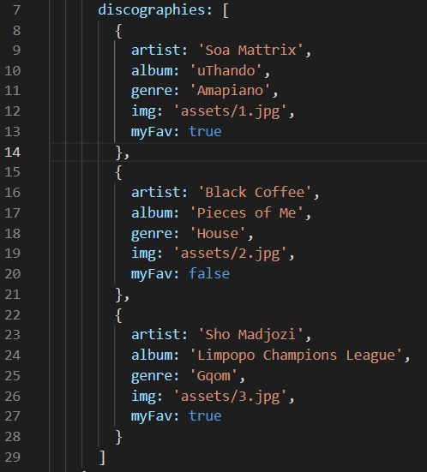

**Step 2:** In the **index.html** file, bind the class attribute to an item in the list. Attach the fav class to all values where the data attribute **myFav** is **true**.

Look at the example below (**Line 23**):

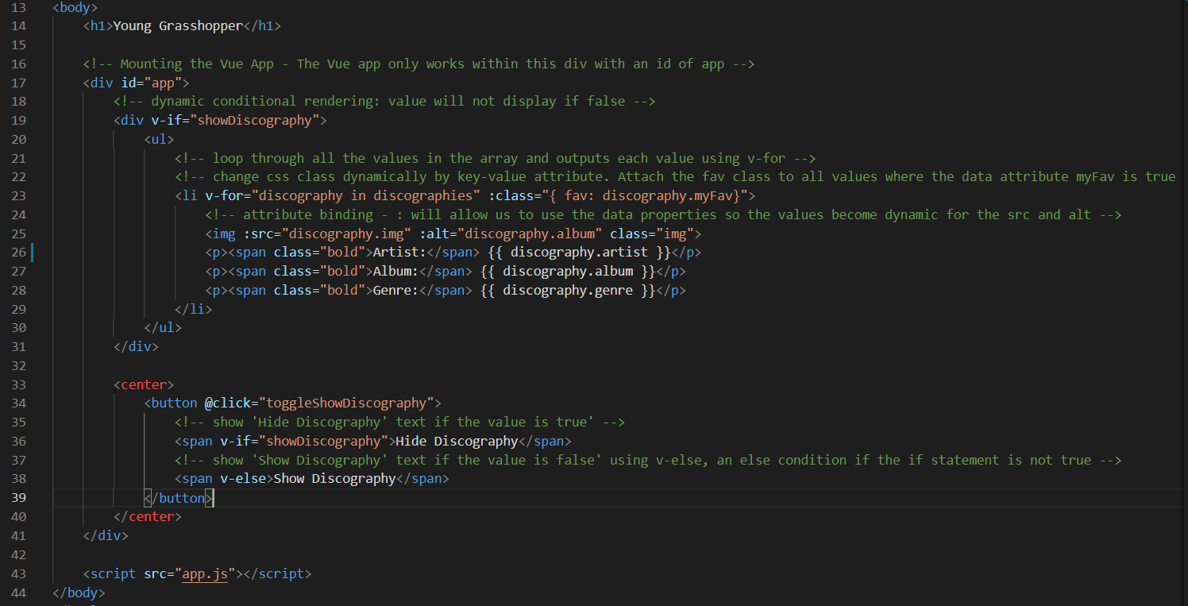

**Output:**

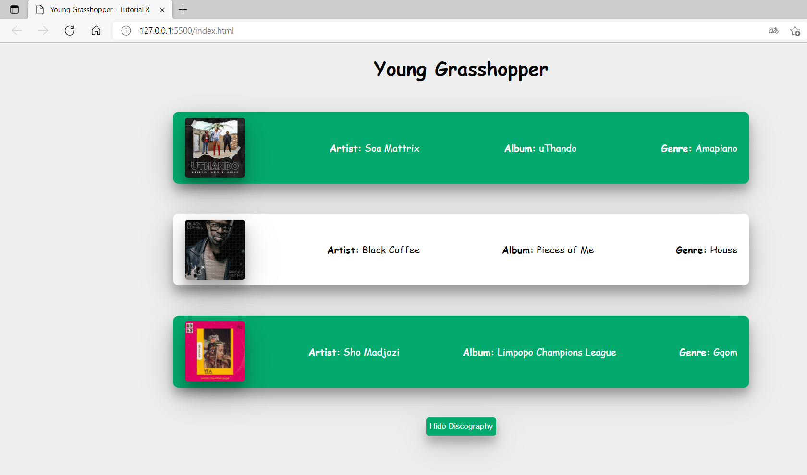

**Step 3:** In the **app.js** file, create a function called **toggleFav** that takes a parameter called discography which will be an object that will be passed that changes the **myFav** item in the object property to the opposite **Boolean** when the function is called.

Look at the example below (**Line 36 to 38**):

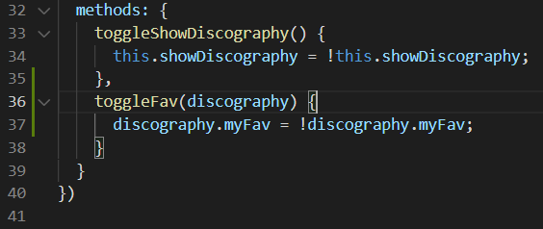

In the **index.html** file, create a click event with the function **toggleFav** created in the **app.js** file and pass the argument **discography** (which was created in the v-for). This will allow us to access the specific object that we are select when clicking on the specific discography.

Look at the example below (**Line 23**):

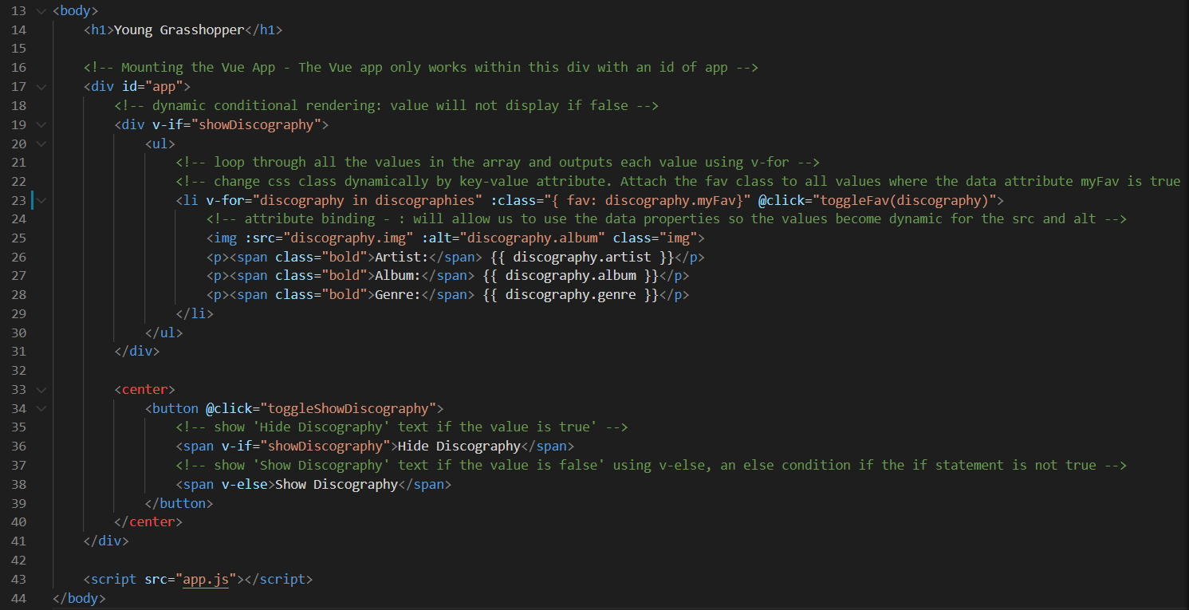

Click on the different discography and watch the fav class dynamically change.

**Output:**

I select the first discography, Soa Mattrix.

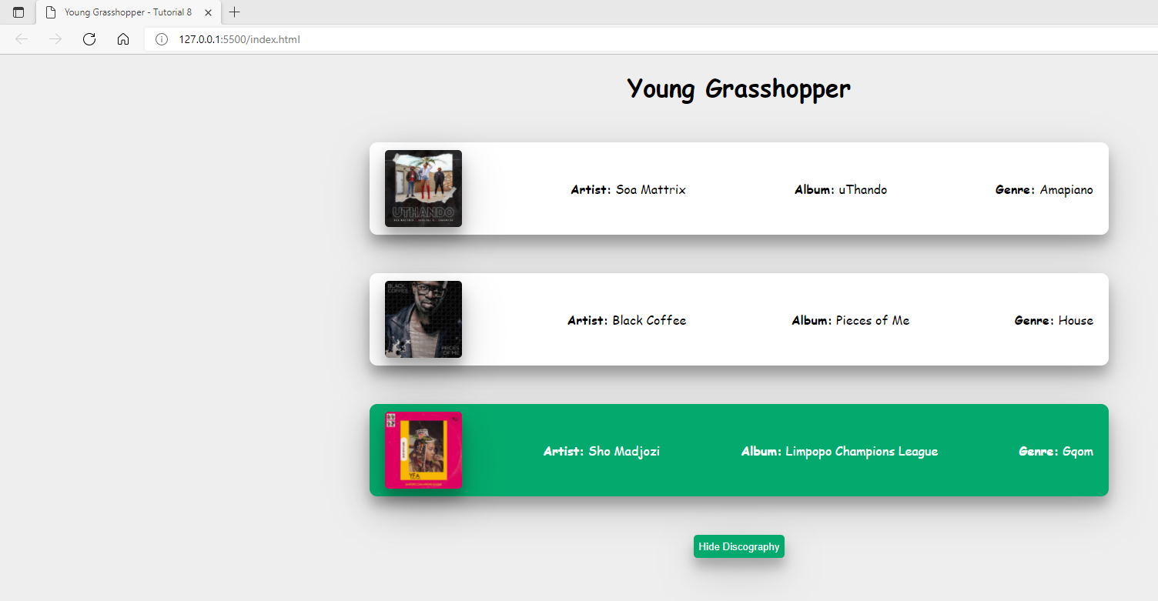

**You can view the code snippets from the** [**vue3-firebase-course**](https://github.com/younggrasshopperza/vue3-firebase-course) **repository under the Tutorial-8 branch.**